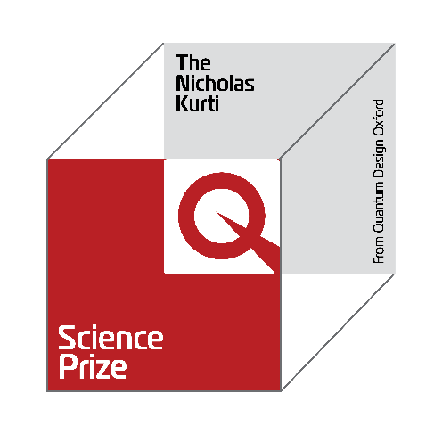
NOMINATION
FORM

CLOSING DATE FOR SUBMISSIONS FOR THE NICHOLAS KURTI PRIZE 2026 IS 30TH APRIL

REQUIREMENTS
- PLEASE INCLUDE ALL OF THESE FILES IN ONE PDF DOCUMENT
- Two letters of support
- Candidate CV
- Up to three papers relevant to the application
  - Include a paragraph on each of the papers describing the importance and impact of that paper, as well as the candidate’s contribution to the research reported in that paper
- Career summary of the candidate
- The candidates’ achievements, impact and originality, and the role of the research group in a manner which can be understood by researchers in other fields

THE NOMINATOR (PLEASE USE BLOCK CAPITALS)

NAME: ___________________________________________________ | TITLE: _____________________________________
ADDRESS: ________________________________________________________________________________________________
TELEPHONE: _____________________________________________ | EMAIL: _____________________________________
AFFILIATION: ______________________________________________________________________________________________

THE CANDIDATE (PLEASE USE BLOCK CAPITALS)

FIRST NAME: _____________________________________________ | SURNAME: ________________________________
TITLE: ___________________________________________________ | MALE/FEMALE: ____________________________
DATE OF BIRTH: __________________________________________ | PHD COMPLETION DATE:  (DD/MM/YY) _________________________________
CANDIDATES HOME ADDRESS: _____________________________________________________________________________
TELEPHONE: _____________________________________________ | FAX: ___________ | EMAIL: ___________________
AFFILIATE’S ADDRESS: _____________________________________________________________________________________
TELEPHONE: _____________________________________________ | FAX: _____________ | EMAIL: ___________________

THE RESEARCH
Proposed citation on the award for the Nicholas Kurti Science Prize
(50 words or less):

THE CANDIDATE’S CAREER HISTORY
Career summary of applicant (including any prizes awarded):

THE CANDIDATE’S ACHIEVEMENTS
Please summarize achievements, their impact and originality, and the
role of the research group in a manner which can be understood by
researchers in other fields.
(Please continue on another sheet if needed, maximum 2 pages
in 12 pt font, single spaced with 1” margins)

THE MAIN PUBLICATIONS
List of main publications (please give the title of the paper, authors, journal’s name,
volume, publication date and page. Please also attach files of up to three papers
relevant to the application) and include a paragraph on each of the papers describing
the importance and impact of that paper as well as the candidate's contribution to the
research reported in that paper (please continue on another sheet if needed).

THE REFEREES (PLEASE USE BLOCK CAPITALS)

1. NAME: _____________________________________ | TELEPHONE: _________________________________
AFFILIATION: ________________________________ | EMAIL: __________________________________
2. NAME: _____________________________________ | TELEPHONE: _________________________________
AFFILIATION: ________________________________ | EMAIL: __________________________________
NOTE: At least one of the referees must be from a different affiliation from the nominator

NOTES
1. All references and papers to be in English
2. Deadline for submission is on 30th April 2026
3. If you experience any difficulties, please email us at qd-oxford@wearetfd.com

